**HAZARDOUS AREA MONITORING FOR INDUSTRIAL PLANT**

**POWERED BY IOT.**

**A PROJECT REPORT**

**Submitted by**

|  |  |
| --- | --- |
| **HARIHARASUDHAN T** | **(20BEC302)** |
| **BALAJI M** | **(20BEC308)** |
| **GOKUL K** | **(20BEC310)** |
| **GOKUL PRASATH M** | **(20BEC320)** |

**DEGREE : BACHELOR OF ENGINEERING/TECHNOLOGY**

**BRANCH : ELECTRONICS AND COMMUNICATION**

**ENGINEERING**

**YEAR OF PASSING**

**:2023**

**COLLEGE : DR. MAHALINGAM COLLEGE OF ENGINEERING AND TECHNOLOGY**

**TEAM ID : PNT2022TMID0886**

**TABLE OF CONTENTS**

**CONTENTS**

1. **INTRODUCTION**

Project Overview

Purpose

1. **LITERATURE SURVEY**

Exis ng problem

References

Problem Statement Defini on

1. **IDEATION & PROPOSED SOLUTION**

Empathy Map Canvas

Idea on & Brainstorming

Proposed Solu on

Problem Solution fit

1. **REQUIREMENT ANALYSIS**

Functional requirements

Non-Functional requirements

1. **PROJECT DESIGN**

Data Flow Diagrams

Solution & Technical Architecture

User Stories

1. **PROJECT PLANNING & SCHEDULING**

Sprint Planning & Estimation

Sprint Delivery Schedule

Reports from JIRA

1. **CODING & SOLUTIONING**

**(Explain the features added in the project along with code)**

Feature 1

Feature 2

Database Schema

1. **TESTING**

Test Cases

User Acceptance Testing

1. **RESULTS**

Performance Metrics

1. **ADVANTAGES & DISADVANTAGES**

1. **CONCLUSION**
2. **FUTURE SCOPE**
3. **13. APPENDIX**

Source Code

GitHub & Project Demo Link

**INTRODUCTION:**

Project Overview:

To monitor the temperature parameters of the hazardous areas in industrial plants. The area is integrated with smart beacon devices every employee working there will be given smart wearable device.

With beacon scanners the employees can view the temperature on his smart wearable device and if the temperature is high, they will receive the alerts to the mobile through SMS, the information is sent to the cloud and through that, the in-charge of that particular plant can view the data and take safety precautions priorly.

Purpose:

For safety purpose it is used in the industry areas since any discrepancies may happen anytime but prior safety alert has to be given by monitoring the area. Surveillance is a major issue in public restricted areas. The robot is hired here to monitor throughout the day, his robotic vehicle has ability to substitute the human in hazardous area to provide surveillance for the betterment of the industry these are installed and maintained for the industry purpose. They keep a check of all the things to be delivered at the ease without any problems.

**LITERATURE SURVEY:**

Existing problem

Working in radiated and harmful environment and become chronic to various diseases and this could be avoided by the development in the industry like installing monitoring systems. Hazardous classified locations are areas where the possibility of fire or explosion hazards may exist under normal or abnormal conditions because of the presenceof flammable, combustible or ignitable gases, vapors, liquids, dust, or fibersDetermining the class, division and group and a particular group is criticalto correctly applyingthe requirements for a givenhazardouslocality.

References

IEEE Papers:

[2022 International Conference on Electronics](https://ieeexplore.ieee.org/xpl/conhome/9751779/proceeding) [and Renewable Systems(ICEARS)](https://ieeexplore.ieee.org/xpl/conhome/9751779/proceeding)

[2020 International Conference on](https://ieeexplore.ieee.org/xpl/conhome/9177229/proceeding) [Communication and SignalProcessing](https://ieeexplore.ieee.org/xpl/conhome/9177229/proceeding) [(ICCSP)](https://ieeexplore.ieee.org/xpl/conhome/9177229/proceeding)

[20166th International Conferenceon System](https://ieeexplore.ieee.org/xpl/conhome/7838016/proceeding) [Engineering and](https://ieeexplore.ieee.org/xpl/conhome/7838016/proceeding)

[Technology (ICSET)](https://ieeexplore.ieee.org/xpl/conhome/7838016/proceeding)

**PROBLEM STATEMENT DEFINITION:**

Employees working in the industry, nearby office and resident people can be safe guarded by the precautions that can be taken in the industry. How significant it is and why does it matter compared to otherways are being analyzed

**IDEATION & PROPOSED SOLUTION:**

EMPATHY MAP CANVAS:

It Creates an effective solution requires understanding the true problem and the person who is experiencing it. The exercise of creating the map helps participants consider things from the user’s perspective along with their goals and challenges.

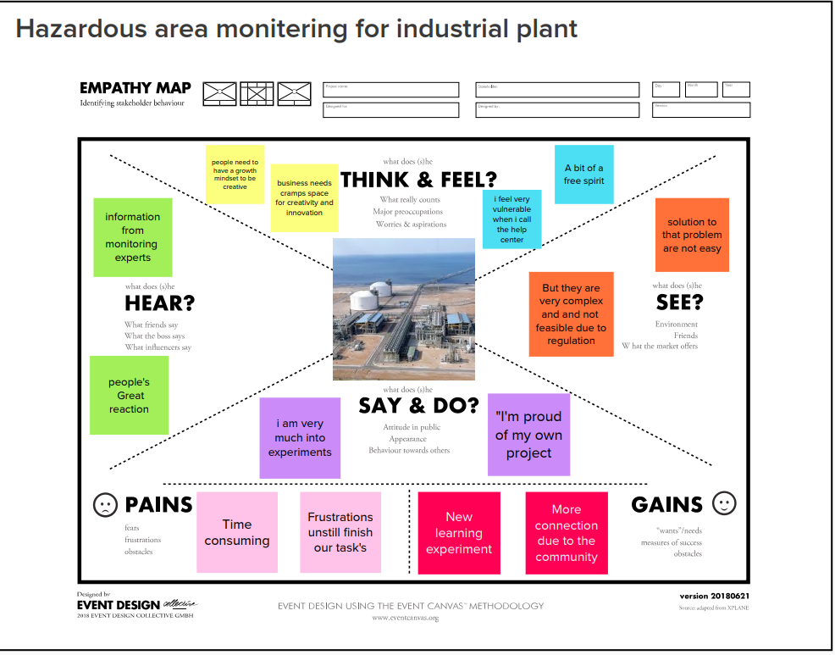

**IDEATION & BRAINSTORMING:**

Brainstorming techniques are proven frameworks for coming up with lots of ideas quickly Establishing an ideation mindset and encouraging creative thinking will benefit your organization in the long term, and finding new ways to push your team in the direction of generating effective ideas has positive effects for your whole organization. Smart sensors for hazardous areas monitor key parameters of assets such as motors and pumps and provide detailed insights into their performance and health.

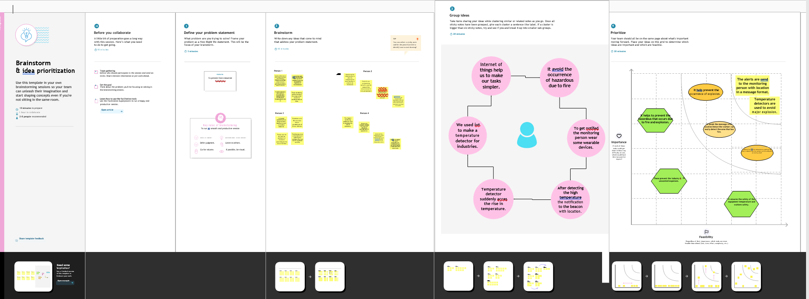

**PROPOSED SOLUTION:**

Many advancements such as augmented reality, automatic identification, indication and many new technologies. Prewarning systems has been integrated so based on these the newly proposed the required solution can be verified effectively. Leading global technology company that energizes the transformation of society and industry to achieve a more productive, sustainable future. By connecting software to its electrification, robotics, automation and motion portfolio, ABB pushes the boundaries of technology to drive performance to new levels.

|  |  |  |
| --- | --- | --- |
| S.No. | Parameter | Description |
|  | Problem Statement (Problem to be solved) | To keep an track in industrial power plant area to avoid hazardous problems in the industry to keep the surroundings and people safe during working. |
|  | Idea / Solution description | Real time location systems (RTLS) are indoor tracking systems capable of location and monitoring people and company assets operating within a defined zone covered by a radio frequency (RF) network. They work through a connected network of RF receivers and active RFID transmitters to provide precise and accurate indoor tracking services for each staff member.  In industry and mining, positioning brings great benefits and by knowing the exact location of people and objects is often vital and can be achieved with monitoring system |
|  | Novelty / Uniqueness | In this the exact location information can be shared periodically and also the environmental conditions of the each and every area can be monitored.  It will be also very helpful at the pandemic situation to monitor the hazardous area from a safer place.  It also help to rescue the workers at the dangerous situation and guide them to safer place. |
|  | Social Impact / Customer Satisfaction | Avoids large scale hazards in industries and saves the environment & people  By this solution we increase the safety of the workers and also the security of the workers  The workers are in the healthy and perfect environmental conditions.  And the peoples surrounded by this kind of industries or environment can be rescued before any danger caused.  Through this we can rescue the peoples get struck in mining as monitoring their positions and also help from the heavy production losses and there by provide affordable or value for money services to the customers. |
|  | Business Model (Revenue Model) | We can sell this technology to the industries and also to the small scale and large scale industries to develop their industrial security and well development.  For example like for the rescue operation we may offer our services to the team as a contract for a period of time to make revenue. |
|  | Scalability of the Solution | The scalability on this model involves more demand on safety and security of workers and the companies too.so, the danger caused are get reduced by this system. And we need lesser man power to work with this kind of activities |

**PROBLEM SOLUTION FIT:**

Customers constriants, Segments, behaviors problem root cause, solutionto the problems are given based on the solutionfit that hasto be given for the proper monitoring.

PURPOSE:

Solve complex problems in a way that fits the state of your customers.

Succeed faster and increase your solution adoption by tapping into existing mediums and channels of behavior.

Sharpen your communication and marketing strategy with the right triggers and messaging.

Increase touch-points with your company by finding the right problem-behavior fit and building trust by solving frequent annoyances, or urgent or costly problems.

Understand the existing situation in order to improve it for your target group.

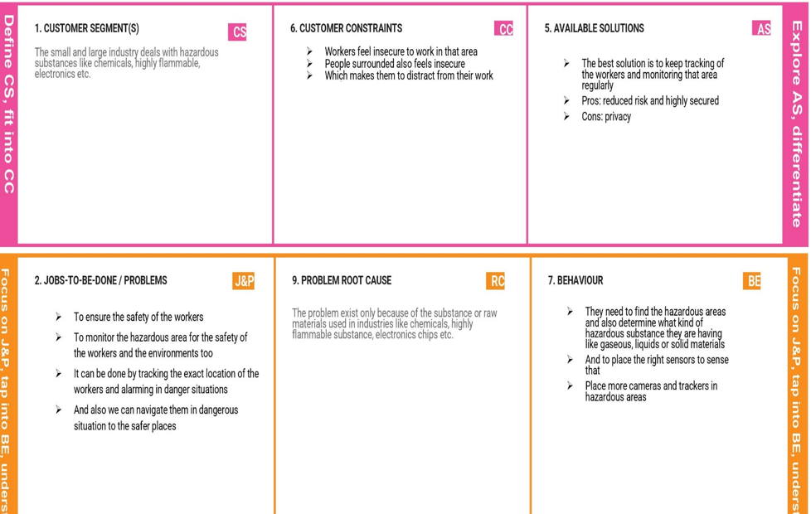

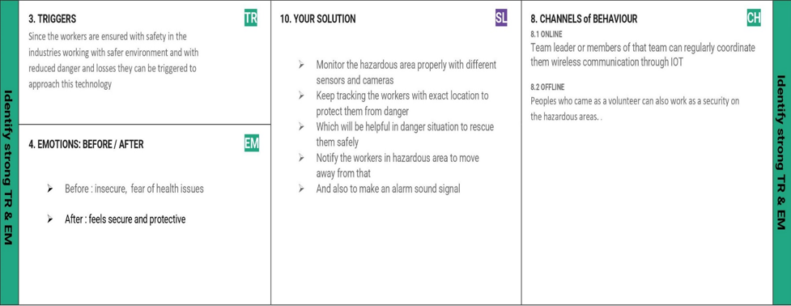

**REQUIREMENT ANALYSIS:**

FUNCTIONAL REQUIREMENT

User registration, verification, authentication and notification has been given based on the needs of the requirements of the industrial area.

|  |  |  |
| --- | --- | --- |
| FR  No. | FunctionalRequirement  (Epic) | SubRequirement(Story/Sub-Task) |
| FR-1 | DataGathering | The smart beacon must be able to accurately determine the temperature of a specific area. |
| FR-2 | LocationDetection | A wearable device entering a dangerous region must be recognised by the smart beacon. |
| FR-3 | BeaconDataSyncing | The smart beacon must be able to share itsstored data with both the wearable deviceandadmindashboardthroughthecloud. |
| FR-4 | WearableDeviceDisplay | The temperature of the location where the worker is present must be displayed by the wearable device. |
| FR-5 | SMSNotification | The workers should be informed through SMS to their phone that they need to leave the location if it is determined that the temperature has reached dangerous levels. |
| FR-6 | AdminDashboard | The admin is notified via the dashboard if the temperature is found to have reached dangerous levels, and they must then take the appropriate safety measures. |

NON-FUNCTIONAL REQUIREMENTS:

Performance, usability, security has to be assured based on these requirements the way of using the resource can be accomplished.

|  |  |  |
| --- | --- | --- |
| FR  No. | Non-FunctionalRequirement | Description |
| NFR-1 | Usability | The wearable  device should be slim and shouldn't irritate or distract the workers who are wearing it.  They should also clearly notify the workers when danger is identified and show the temperature consistently without significant delays. |
| NFR-2 | Security | The connection of the beacons to the cloudandwearabledevicesshould besecure.  The security of the database that stores all of the temperature data needs to be strengthened. |
| NFR-3 | Reliability | Even at harmful temperatures, the wearable device should be able to operate without any issues.  If a problem is found, it should alert the user and the admin so it can be fixed immediately.  For reliability, the beacons should also get routine maintenance. |
| NFR-4 | Performance | High end sensors and processors are needed for the device to update temperature values in real time.  It is important to minimise the time it takes for data to be sent to the cloud and other devices. |
| NFR-5 | Availability | Regardless of where they are or what time it is, the user should be able to monitor the temperature of the region.  In order to guarantee that safety measures may be taken when danger is recognised, the dashboard should be enabled at all times. |
| NFR-6 | Scalability | Installing more smart beacon devices and connecting them to the same system as the existing beacons is all that is required to expand the area that needs to be watched.  It is also extremely scalable because it may be repeated in several plants with various variables to be tracked. |

**DATA FLOW DIAGRAMS:**

Basic representation of the system flow is followed,

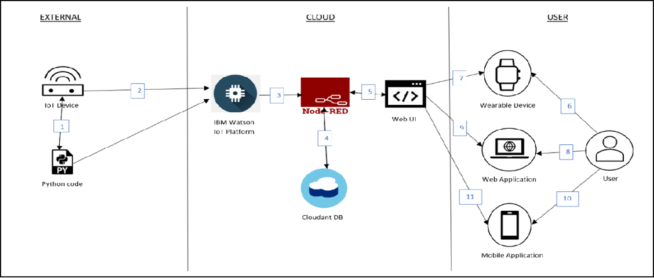

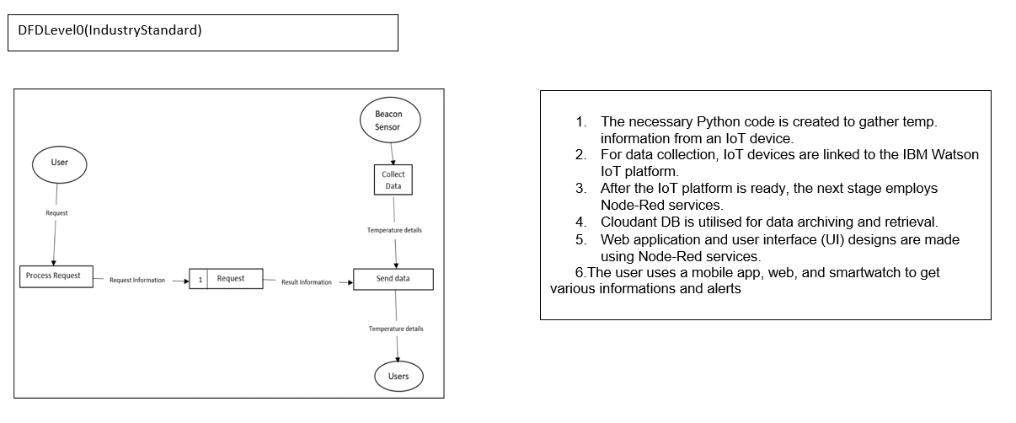

**SOLUTION & TECHNICAL ARCHITECTURE**:

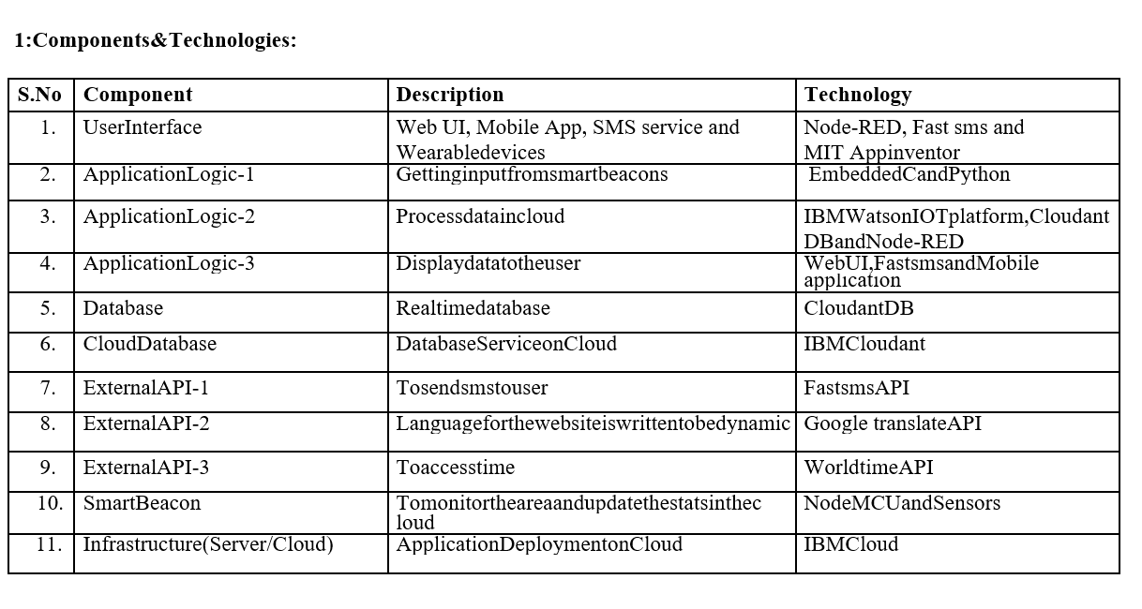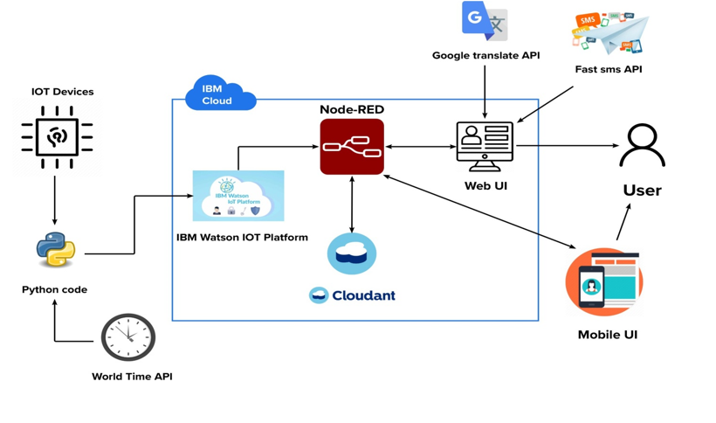

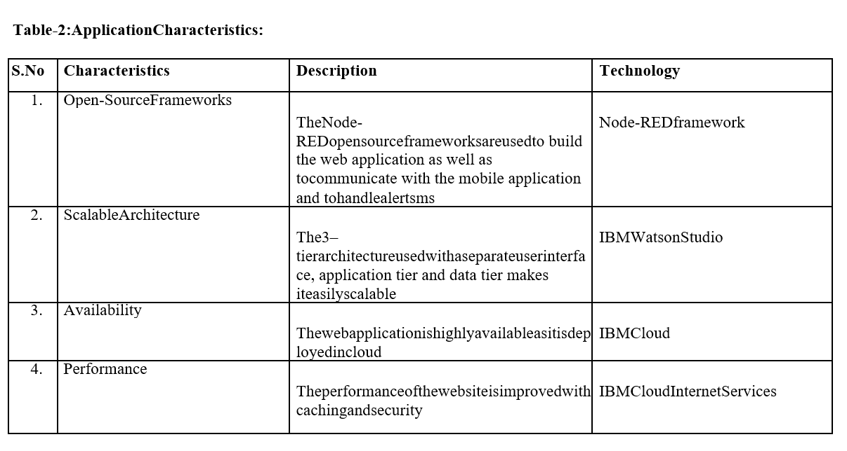

**USER STORIES:**

All the customer’s needs are given based on the requirements that are necessarily available and building up the right architecture needed. The robot is hired here to monitor throughout the day. This robotic vehicle has ability to substitute the human in hazardous area to provide surveillance.

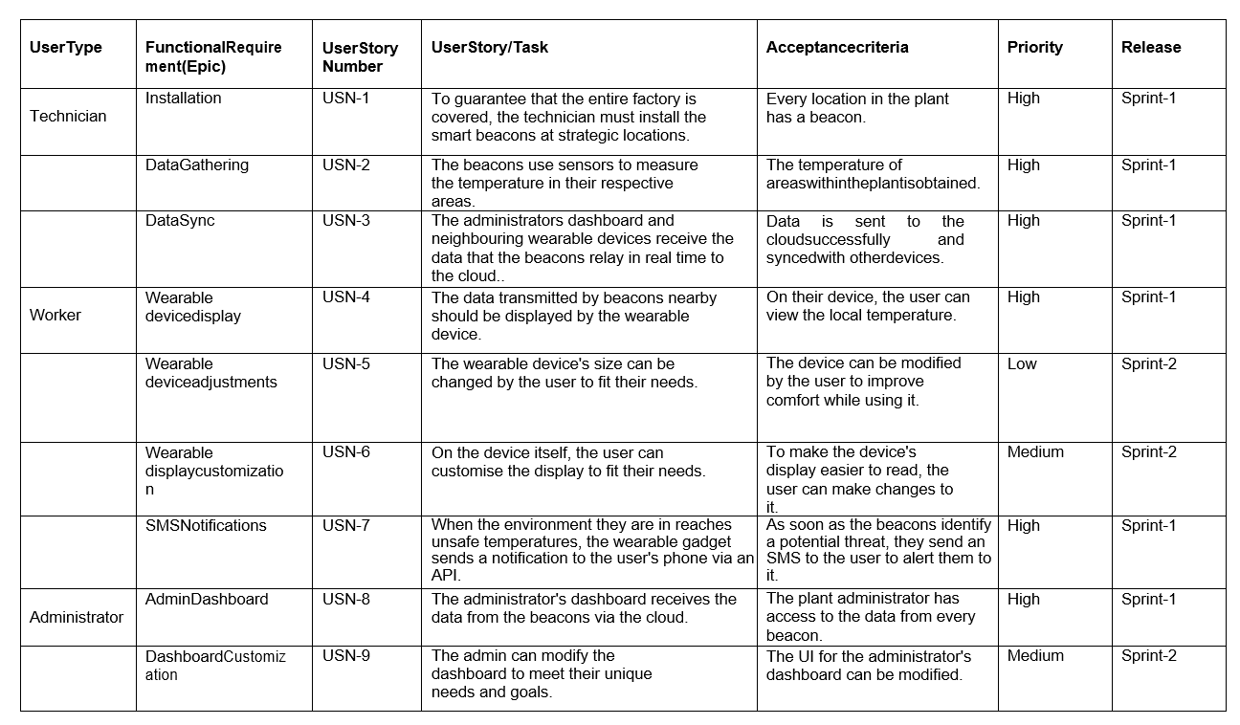

**PROJECT PLANNING& SCHEDULING:**

SPRINT PLANNING & ESTIMATION:

Creation of Watson IOT, Node-Red and the MIT app inventor are being proposed for the delivery if the sprints it is totally based on the system administration that has to take place in the estimation of the sprint is given by the output obtained.

Sprint Delivery Schedule:

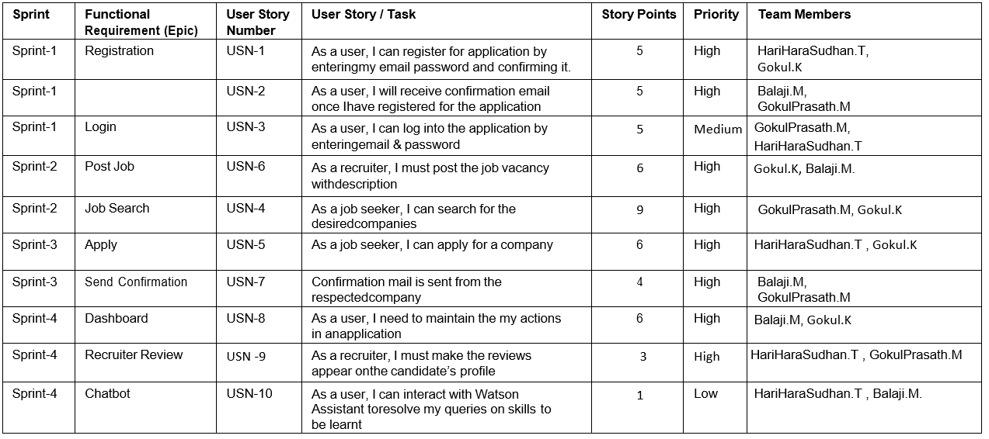

**CODING & SOLUTIONING:**

Feature 1:

From Node red HTTP link has been created and this is used in MIT app for the creation and the used code is given below,

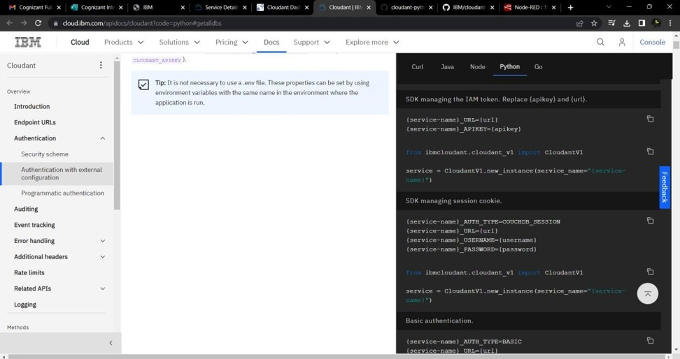

Creating device in the IBM Watson IoT platform.

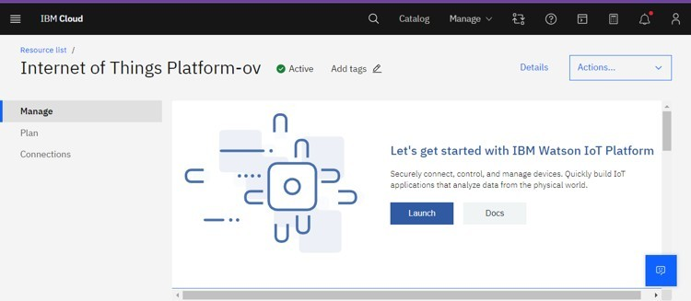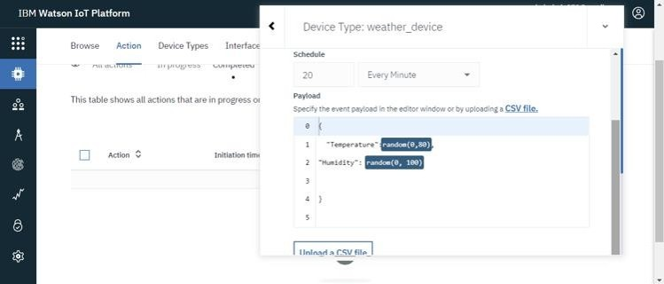

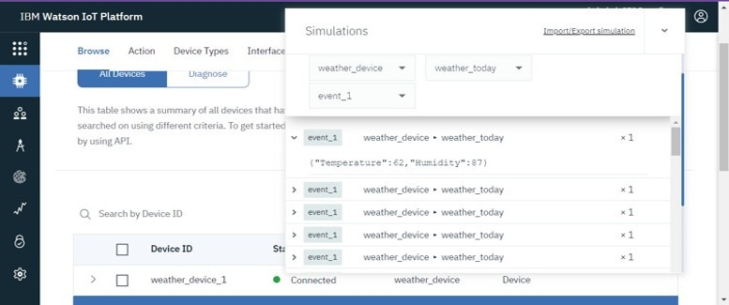

Displaying charts for temperature and humidity values fetched from weather monitoring device created in IBM Watson IoT platform.

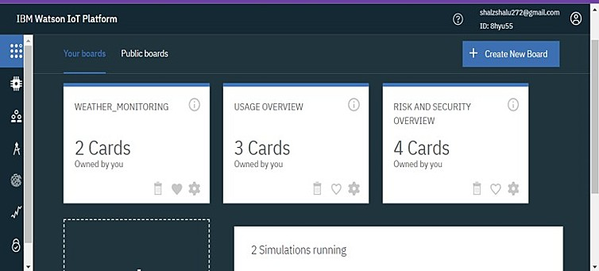

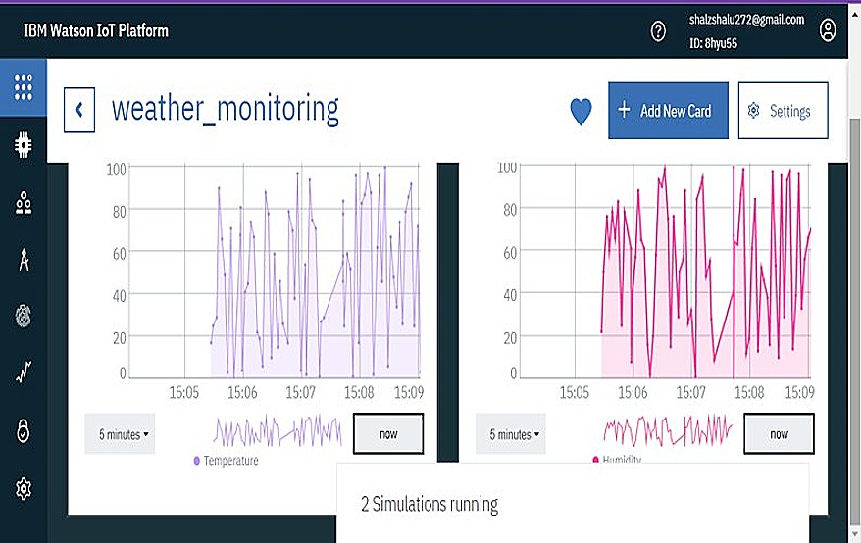

Unique API and authentication key generated from IBM Watson IoT platform for the weather monitoring device (here, Device name:Weather monitoring) is used to connect the device created in IoT platform (IBM clou) to Node-RED workflow.

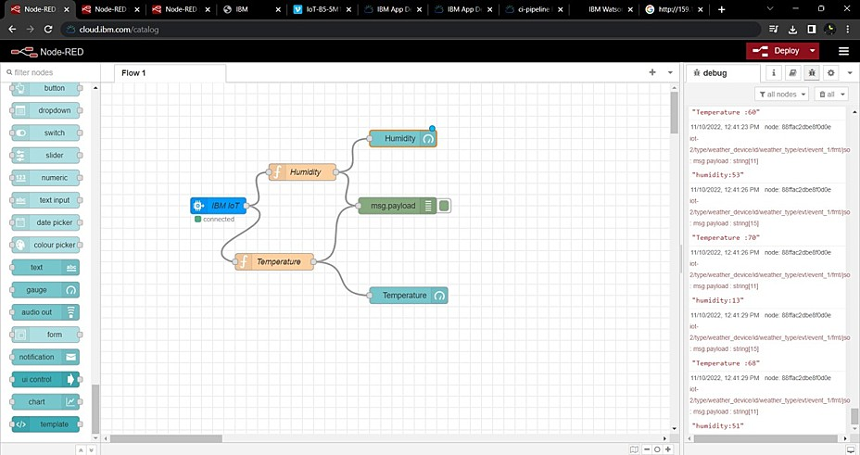

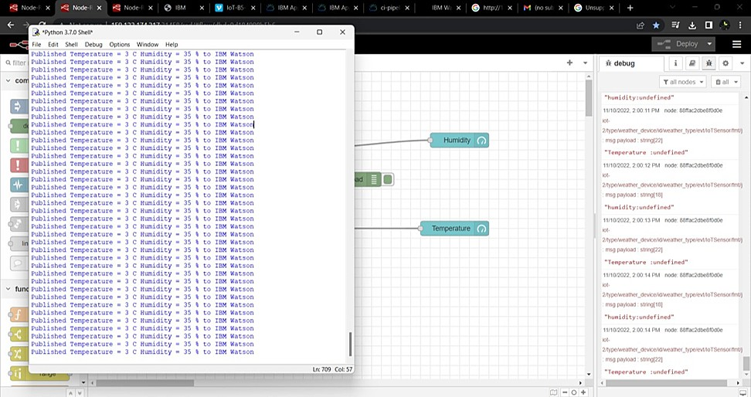

Unique device credentials for the weather monitoring device created in IoT platform is dumped into python code and Internal device simulator is ON for the same device to fetch parameters like temperature and humidity when node flow is deployed

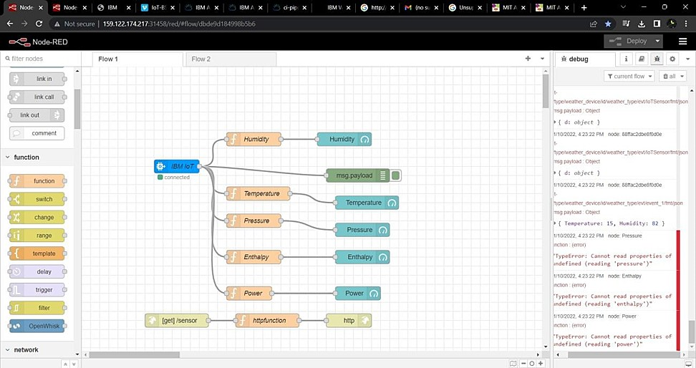

Creating dashboard for the work flow scenario created in Node-RED.

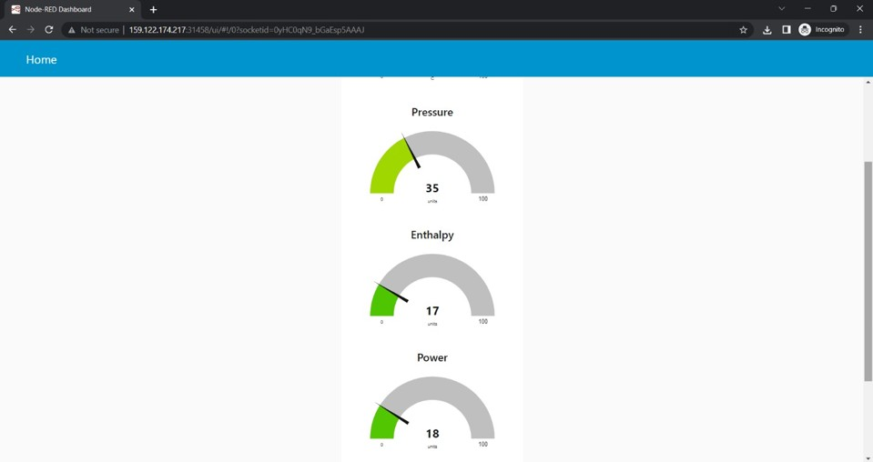

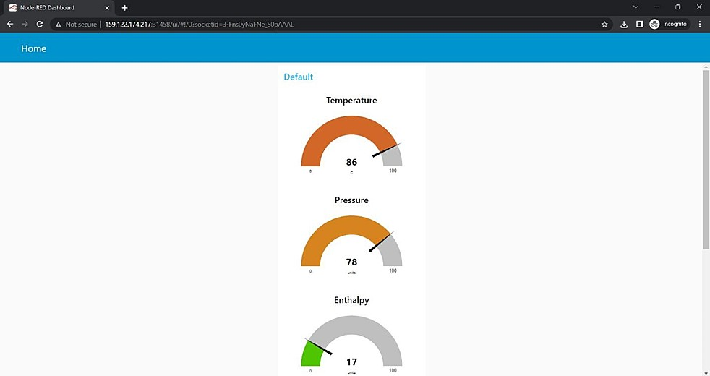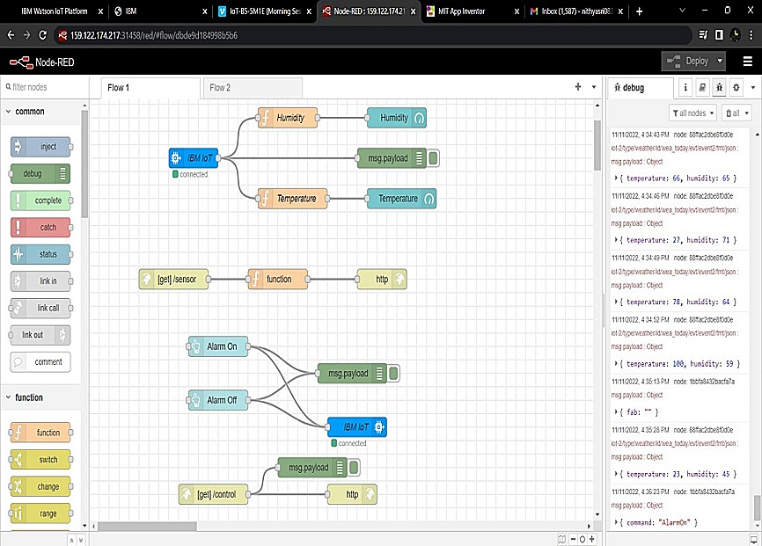



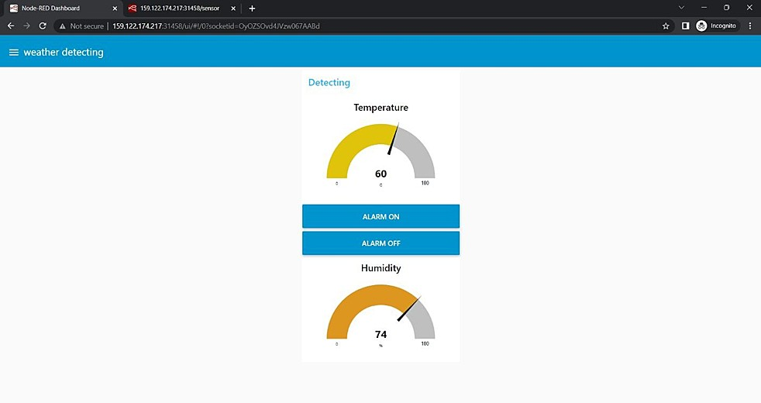

Alarm will be ON if temperature reaches critical point and OFF when in acceptable level.

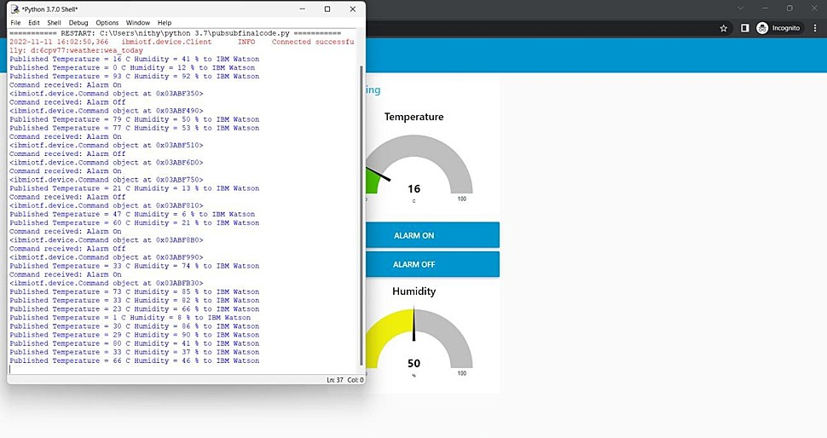

Creating a node flow for getting http(URL) , using http in and response nodes.

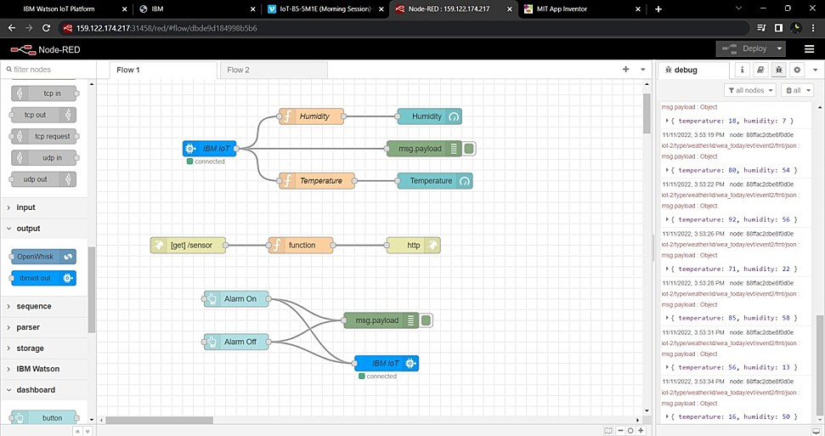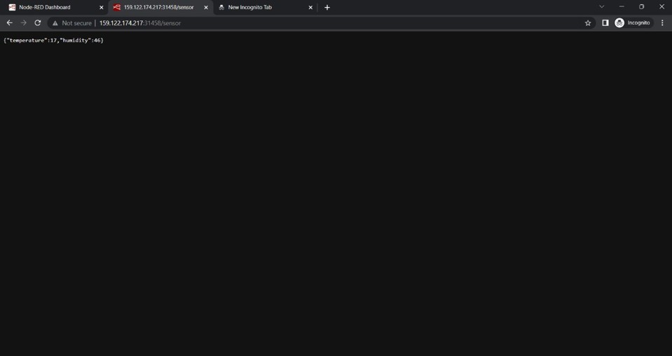

Building block codes for deploying hazardous area monitoring app.

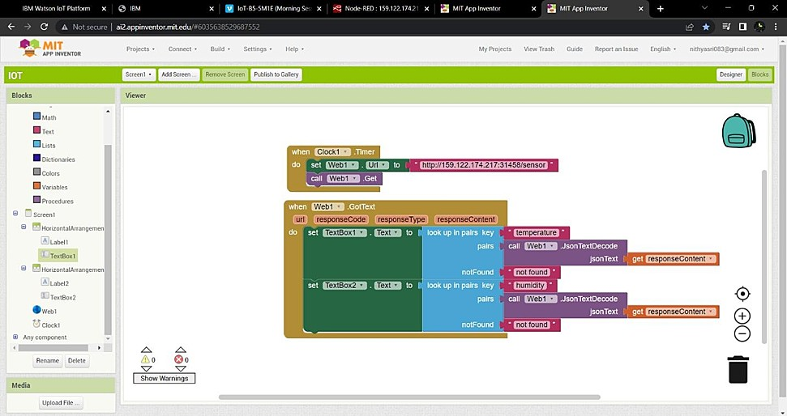

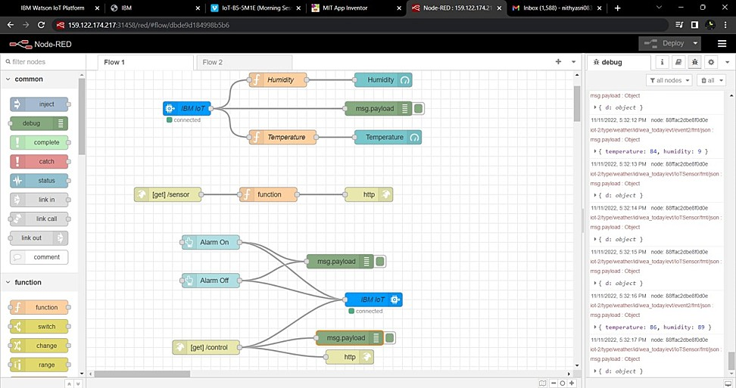

Using GET function in block codes which allow us to request http (URL) of Node-RED workflow and a clock timer ( 1 sec ) is set to get reading or information on temperature and humidity of industrial plant at remote location for every second sequentially.

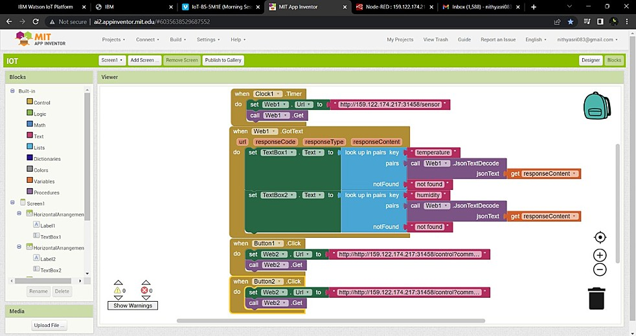

App is deployed for monitoring industrial plant with alarm ON and OFF features thus avoiding certain unexpected accidents industrial plants.

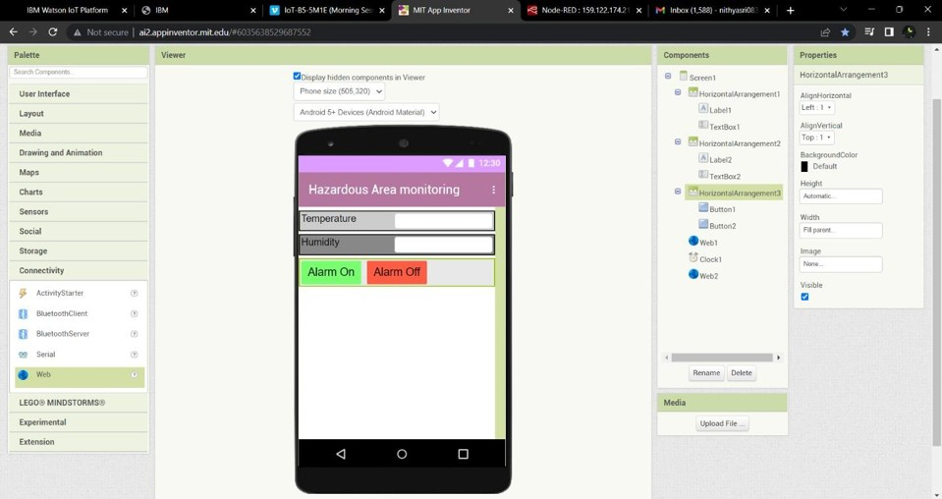

Feature 2:

Temperature and Humidity is being measured using the final code given in the MIT application

DATABASE SCHEMA :

HTTP link generated from node red is being taken so this is the only database that has been taken since HTTP link createdin the node red is being obtained for the MIT application for the sensing of temperature and humidity.



TESTING:

Test Cases

The main test case is to deliver the Temperature and Humidity of the hazardous area if there is an increase in temperature there would be an alert message through which we can take safety measures priorly.

User Acceptance Testing

To input the code based on the accepteduser input is being testedfor the purposeof obtaining the desired output.

RESULTS:

Performance Metrics

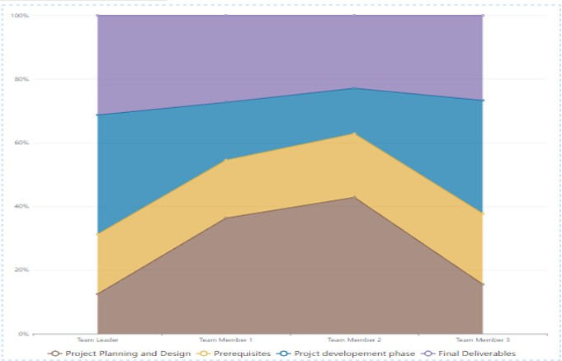

ADVANTAGES & DISADVANTAGES ADVANTAGES:

ADVANTAGES

Constant measurement of relative temperature and humidity is done so that there are no discrepancies.

Information of power and energy consumption is lessened upto 10%.

DISADVANTAGES:

Smart sensors for hazardous areas monitor are the key parameters if these face anyproblemthere would be a major failure in the whole monitoring system.

Accessing immediately to the hazardous areas is diﬃcult hence it is costly and time-consuming to monitor the condition and their performance.

CONCLUSION:

The hazardous area is being monitored using the temperature and humidity sensors.

FUTURE SCOPE:

Safety precautions are relatively more than the usual monitoring system.

The way of using these without manual input can be upgraded even more for the betterment than these technologies used in our generation.

Safety of the employees in the industrial plant is the most important so these systems can make them more secured.

APPENDIX

import time import sys

import ibmiotf.application import ibmiotf. device imports random

Source Code

#Provide your IBM Watson Device Credentials organization = "6cpv77"

deviceType = "weather"

deviceId = "wea_today" authMethod = "token"

authToken = "Fo9af9o00doS8VUsb2"

# Initialize GPIO

def myCommandCallback(cmd):

print("Command received: %s" % cmd.data['command']) status=cmd.data['command']

if status=="Alarm On": print("Alarm is off")

else:

print("Alarm is On") #print(cmd)

try:

deviceOptions = {"org": organization, "type": deviceType, "id": deviceId, "auth-method":

authMethod, "auth-token": authToken}

deviceCli = ibmiotf.device.Client(deviceOptions) #..............................................

except Exception as e:

print("Caught exception connecting device: %s" % str(e)) sys.exit()

# Connect and send a datapoint "hello" with value "world" into the cloud as an event of type "greeting" 10 times

deviceCli.connect()

while True:

#Get Sensor Data from DHT11 temp=random.randint(0,200) humidity=random.randint(0,200) if temp>=100:

print("Alert") else:

print("safe")

data = {"d":{ 'temp' : temp, 'humidity': humidity}} #print data

def myOnPublishCallback():

print ("Published Temperature = %s C" % temp, "Humidity = %s %%" % humidity, "to IBM Watson")

success = deviceCli.publishEvent("IoTSensor", "json", data, qos=0, on_publish=myOnPublishCallback)

if not success:

print("Not connected to IoTF") time.sleep(1)

deviceCli.commandCallback = myCommandCallback

# Disconnect the device and application from the cloud deviceCli.disconnect()

GITHUB & PROJECT DEMO LINK

PROJECT SIMULATION DEMO LINK:

https://drive.google.com/file/d/1y7JIiL3cVgZ7v216KlY9pBZ7fg2lI1YE/view?usp=drivesdk

GITHUB:

gh repo clone IBM-EPBL/IBM-Project-7432-1658855931